Project Report
On



DIGITAL
SIGNATURE

Digital Signature

Prepared by

(MCA – VIth Sem)

Submitted to

Project Guide

DECLARATION

we,…… Names…… student of MCA program, VI Semester of 2006 – 2009 batch at ………. University do hereby declare that this report entitled “Digital Signature“ has been carried out by me during this Semester and the same work has not been copied from any source directly without acknowledging for the part/ section that has been adopted from published / non-published works.

__________________

Acknowledgement

Success is not a destination, but a journey. I have realized it even better during my Internship Program. A journey to the corporate culture with and all those who were associated with it, has fascinated me towards consultancy culture and the feel of working in a healthy and inspirational work environment.

At the outset, I would like to take the opportunity to thank all those people who constantly motivated and provided me with inspirational guidance during the course of my internship.

I express my deepest and most sincere thanks to my project guide, and for all their guidance and help that they have extended throughout the project and provided an inspiration for taking the project to its completion .

A special thanks to our Trainers, who provided me with valuable insights and without whose kind guidance, I would not have been able to complete this course.
Also very much thankful to Mr. Aditiya for all his guidance and help.

I would also like to express my regard to all the staff members, teaching, non-teaching staff and friends for helping me in the course of my endeavor which helped me undertake the project in a better fashion and without whose timely help and inspiration this humble effort would not have taken a proper shape.

INDEX & TABLES

- About Organization
- About Project
- Objective
- Project Profile
- Problem Definition
- Proposed System and Targeted User
7. Specific Requirement Specifications
8. System Development
- Data Design
Entity-Relationship Diagram
- System Design
UML
Data Flow Diagram
- User Interface Design
Screen Shots
- Appendix
- Bibliography

ABOUT THE ORGANISATION

About Organization

Introduction
.

Vision
…………….
- Mission

……………………….

- Values
…………….
- Quality

……………………………..

- Products

About Project

Abstract

The security of information available to an organization was primarily provided through physical and administrative means. For example, rugged file cabinets with a combination lock were used for storing sensitive documents and personnel screening procedures were employed during the hiring process. With the introduction of the computer, the need for automated tools for protecting files and other information stored on the computer became evident.
This is especially the case for a shared system and the need is even more acute for a network. Computer networks were primarily used by university researches for sending e-mail, and by corporate employees for sharing printers. Under these conditions, security was not given much attention. Today, since the world is going global, and trillions of data are transferred daily across networks, security is looming on the horizon as a potentially massive problem. The generic name for the collection of tools designed to protect data and to thwart hackers is Computer Security.
In the project titled “Digital Signatures” security is ensured in the Messaging System of an organization. In this application, if an employee wishes to send confidential information to another employee connected through the intranet of their organization, he

first signs the message and then sends it to the recipient. He signs the message using Digital Signatures. The person who receives the message validates the sender and if the message is from an authorized employee, he reads the message. The above operation is performed using Digital Signature Algorithm (DSA). This application makes sure that the security services Authentication, Secrecy, Integrity, and Non-repudiation are provided to the user. Therefore, intruders cannot gain access to classified information.

2. INTRODUCTION
Scope
The project is confined to the intranet in an organization. This application makes sure that security services such as secrecy, authentication, integrity and non-repudiation are provided to the communicating parties.
Objective
This project has been developed keeping in view the security features that need to be implemented in the networks following the fulfillment of these objectives:

- To develop an application that deals with the security threats that arise in the network.
- To enable the end-users as well as the organizations come out with a safe messaging communication without any threats from intruders or unauthorized people.
- To deal with the four inter-related areas of network security namely Secrecy, Authentication, Non-repudiation and Integrity.
Project Overview
This application makes use of Digital Signature Algorithm (DSA) along with a hash function. The hash code is provided as input to a signature function along with a random number generated for this particular signature. The signature function also depends on the sender’s private key and a set of parameters known

to a group of At the receiving end, verification is performed. The receiver generates a quantity that is a function of the public-key components, the sender’s public key, and the hash code of the incoming message. If this quantity matches with one of the components of the signature, then the signature is validated.
This application makes sure that the security services Authentication, Secrecy, Integrity, and Non-repudiation are provided to the user.
- This application allows to keep the information out of the hands of unauthorized persons. This is called Secrecy.
- It also deals with determining whom a person is communicating with before revealing sensitive information or entering a business deal. This is called Authentication.
- Non-repudiation deals with proving that a particular message was sent by a particular person in case he denies it later.
- Integrity makes sure whether a particular message has been modified or something has been added to it.

Project Profile

► | Product Name | : | DigitalSignature (A secure Messaging system)
► | Project Objective | : | This application makes sure that the security services Authentication, Secrecy, Integrity, and Non-repudiation are provided to the user. Therefore, intruders cannot gain access to classified information.
► | SDLC Model | : | Water Fall Model
► | Development Technologies | : | Java/J2EE
► | Application Server | : | Oracle Weblogic Application Server Enterprise Edition
► | Back-End Database | : | Oracle Database 10g Enterprise Edition
► | Location | : | ………. ,Noida

Problem Definition

Message authentication protects two parties who exchange messages from any third party. However, it does not protect the two parties against each other. Several forms of disputes between the two parties are possible.

For example, suppose that A sends an authenticated message to B. Consider the following disputes that could arise:
- B may forge a different message and claim that it came from A. B would simply have to create a message and append an authentication code using the key that A and B share.
- A may deny sending the message. Because it is possible for B to forge a message, there is no way to prove that A did in fact send the message.

The most attractive solution to this problem is the Digital Signature. The Digital Signature is analogous to the handwritten signature. It must have the following properties:

  - It must be able to verify the author and the date and time of the signature.

  - It must be able to authenticate the contents at the time of the signature.
  - The signature must be verified by third parties, to resolve disputes.

Thus, the digital signature function includes the authentication function.
Based on the above properties, the following requirements can be formulated for the digital signatures:
- The signature must be a bit pattern that depends on the message being signed.
- The signature must use some information unique to the
sender, to prevent both forgery and denial.
- It must be relatively easy to produce the digital signature.
- It must be relatively easy to recognize and verify the digital signature.
- It must be computationally infeasible to forge a digital signature, either by constructing a new message for an existing digital signature or by constructing a fraudulent digital signature for a given message.
- It must be practical to retain a copy of the digital signature in storage.

Proposed System & Targeted User

Existing system
These days almost all organizations around the globe use a messaging system to transfer data among their employees through their exclusive intranet. But the security provided is not of high standards. More and more unauthorized people are gaining access to confidential data.

Disadvantages:
- The validity of sender is not known.
- The sender may deny sending a message that he/she has actually sent and similarly the receiver may deny the receipt that he/she has actually received.
- Unauthorized people can gain access to classified data.
- Intruders can modify the messages or the receiver himself may modify the message and claim that the sender has sent it.

Proposed system
The system will provide the following security services:

Confidentiality:
Confidentiality is the protection of transmitted data from passive attacks. With respect to the release of message contents, several levels of protection can be identified. The broadest service protects all user data transmitted between two users over a period of time. For example, if a virtual circuit is set up between two systems, this broad

protection would prevent the release of any user data transmitted over the virtual circuit. Narrower forms of this service can also be defined, including the protection of a single message or even specific fields within a message. These refinements are less useful than the broad approach and may even be more complex and expensive to implement. The other aspect of confidentiality is the protection of traffic flow from analysis. This requires that an attacker not be able to observe the source and destination, frequency, length, or other characteristics of the traffic on a communications facility.

Authentication:
The authentication service is concerned with assuring that a communication is authentic. In the case of a single message, such as a warning or alarm signal, the function of the authentication service is to assure the recipient that the message is from the source that it claims to be from. In the case of an ongoing interaction, such as the connection of a terminal to a host, two aspects are involved. First, at the time of connection initiation, the service assures that the two entities are authentic (i.e. that each is the entity that it claims to be). Second, the service must assure that the connection is not interfered with in such a way that a third party can masquerade as one of the two legitimate parties for the purposes of unauthorized transmission or reception.
Integrity:
Integrity basically means ensuring that the data messages are not modified. An integrity service that deals with a stream of messages assures that messages are received as sent, with no

duplication, insertion, modification, reordering or replays. The destruction of data is also covered under this service. Thus the integrity service addresses both message modification and denial of service.
Non-repudiation:
Non-repudiation prevents either sender or receiver from denying a transmitted message. Thus, when a message is sent, the receiver can prove that the message was in fact sent by the alleged sender. Similarly, when a message is received, the sender can prove that the message was in fact received by the alleged receiver.

System Requirement Specification

 Client Configuration
Intel Pentium IV or equivalent with :
- 512 MB RAM
- 80GB Hard Disk
- OS: Windows 2000 / XP (includes Internet Explorer version 6)
- Word processing software (Open office / MS Office)
- 100 MBPS Ethernet Card

 Server Configuration
4 Servers each with following configuration :
- 1 CPU
- OS: Windows 2000 / XP (includes Internet Explorer version 6)
- RAM : 16 GB Minimum
- 120GB X 3 Hard Disk
- Oracle Application Server 10g Enterprise Edition
- Oracle Database 10g Enterprise Edition

Database Description

Entity: Login_digisafe
Role: To maintain the username and the related password of different users.
Attributes:

NAME | NULL? | TYPE
Username | Not null | Varchar2
Password | Not null | Varchar2
Question |  | Varchar2
Answer |  | Varchar2
Check1 |  | Number

Entity: Inbox_digisafe
Role: To maintain the received mails of different users.
Attributes:

NAME | NULL? | TYPE
Username_sender | Not null | Varchar2
Username_receiver | Not null | Varchar2
Subject |  | Varchar2
Message |  | Varchar2
Message_digest | Not null | Long raw
Message_key | Not null | Varchar2
Message_date | Not null | Date
Check1 | Not null | Number

Entity: sent_digisafe
Role: To maintain the sent mails of different users.
Attributes:

NAME | NULL? | TYPE
Username_sender | Not null | Varchar2
Username_receiver | Not null | Varchar2
Subject |  | Varchar2
Message |  | Varchar2
Message_date | Not null | Date

Entity: certificate_digisafe
Role: To maintain the certificate of different users.
Attributes:

NAME | NULL? | TYPE
Username | Not null | Varchar2
Cfile |  | Varchar2

Entity: attachment_digisafe
Role: To maintain the files attached with message of different users.
Attribute:

NAME | NULL? | TYPE
Message_date |  | Varchar2
Attach1 |  | Varchar2
Message_digest1 |  | Varchar2
Attach2 |  | Varchar2
Message_digest2 |  | Varchar2
Attach3 |  | Varchar2
Message_digest3 |  | Varchar2
Attach4 |  | Varchar2
Message_digest4 |  | Varchar2
Attach5 |  | Varchar2
Message_digest5 |  | Varchar2

Data Design

E-R Diagram

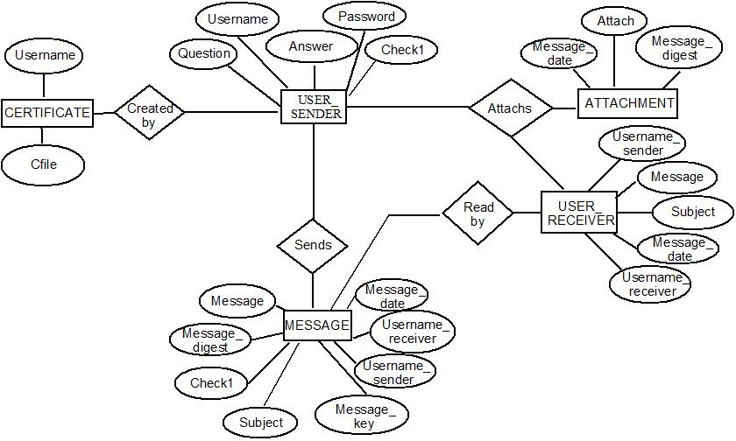

System Design

UML Diagram

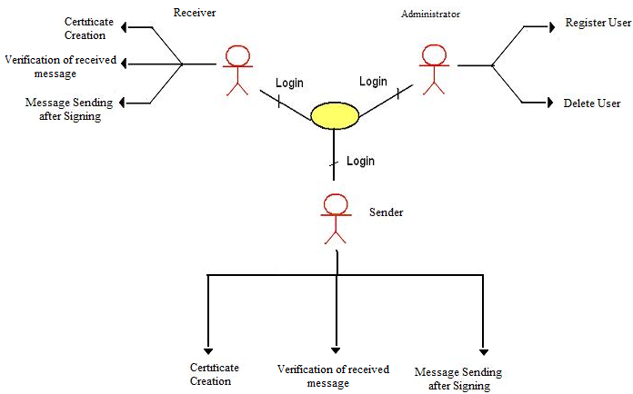

Data flow diagrams

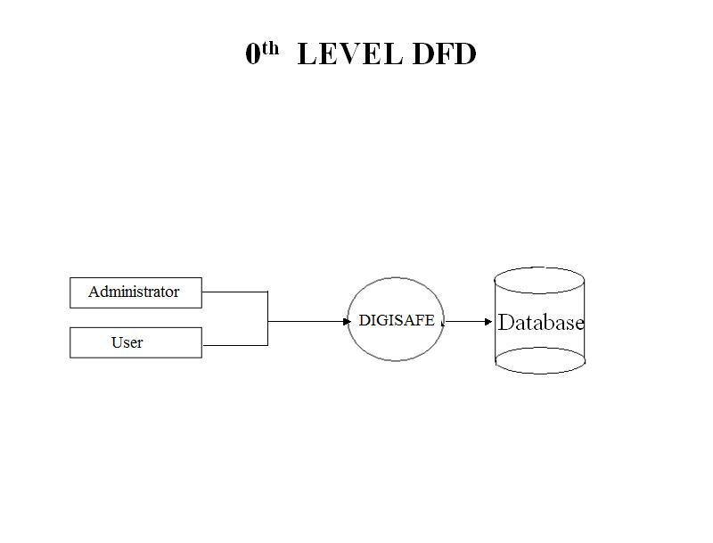

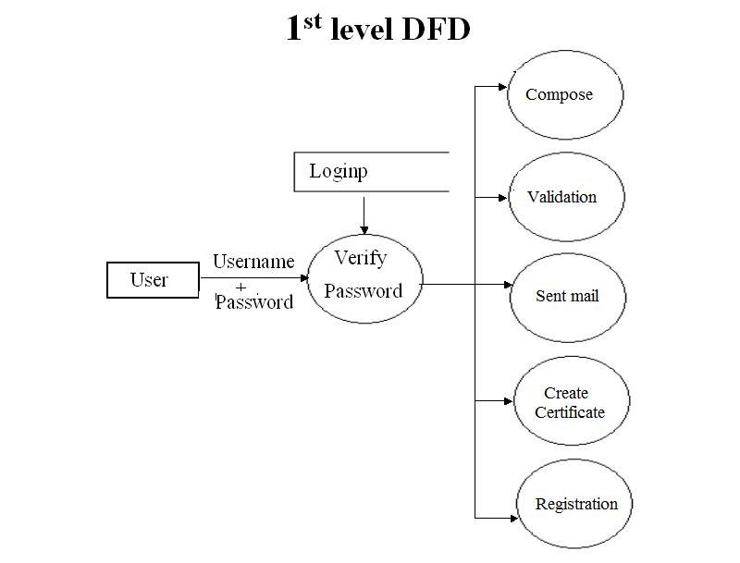

2ND Level DFD’S

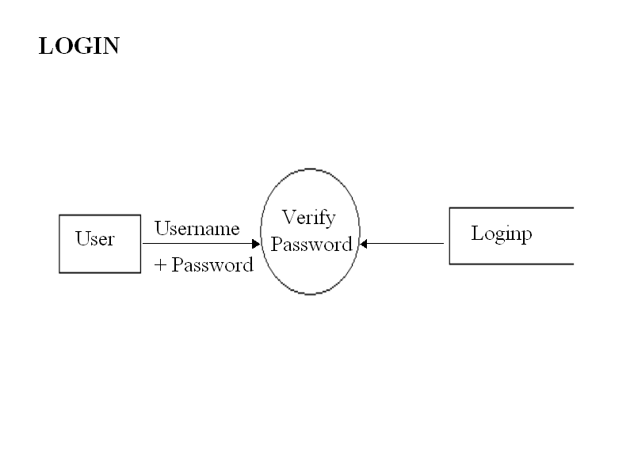

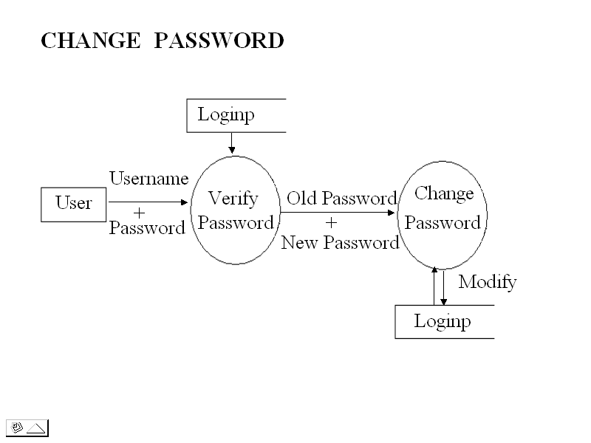

Compose Mail

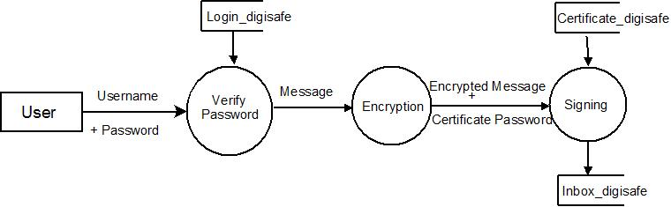

Validate Mail

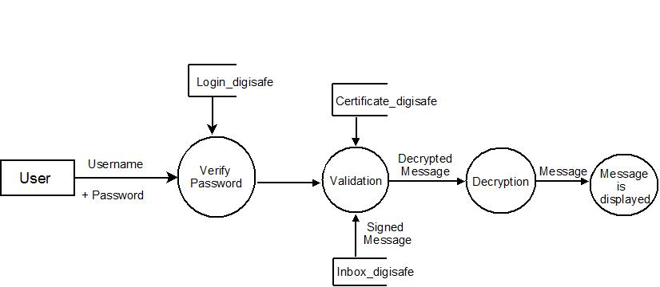

Create Certificate

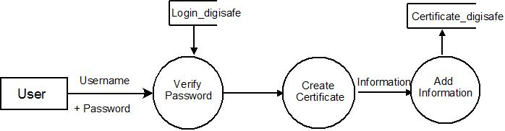

Sent Mail

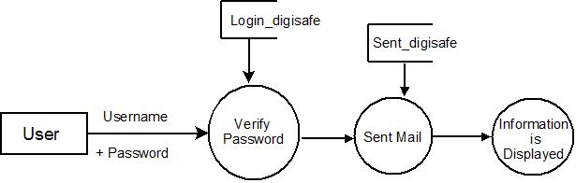

SCREEN SHOTS

Screen Shots

Screen 1 - Login Screen

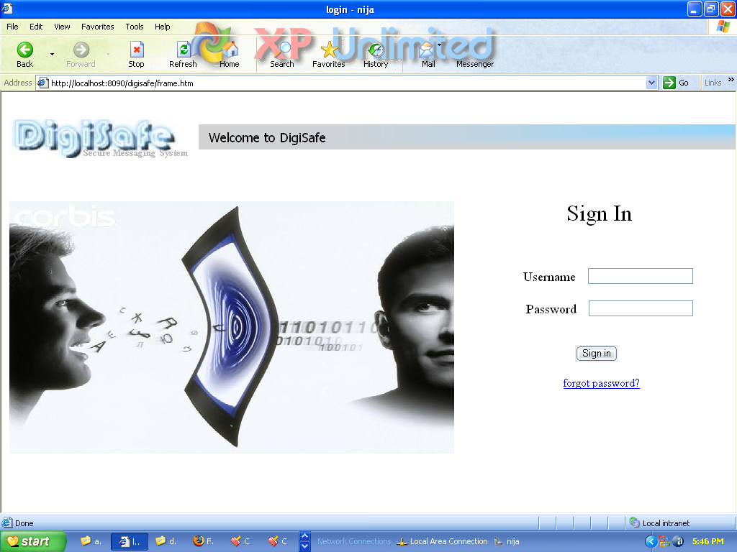

Screen 2 – Home Screen

- This is home page of Administrator

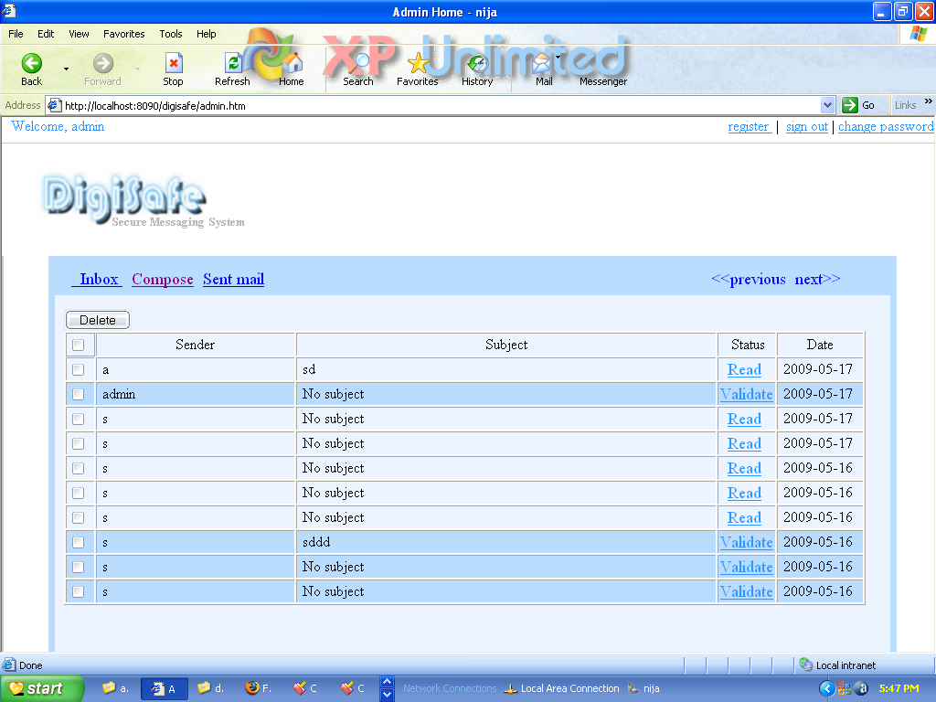

- This is home page of User

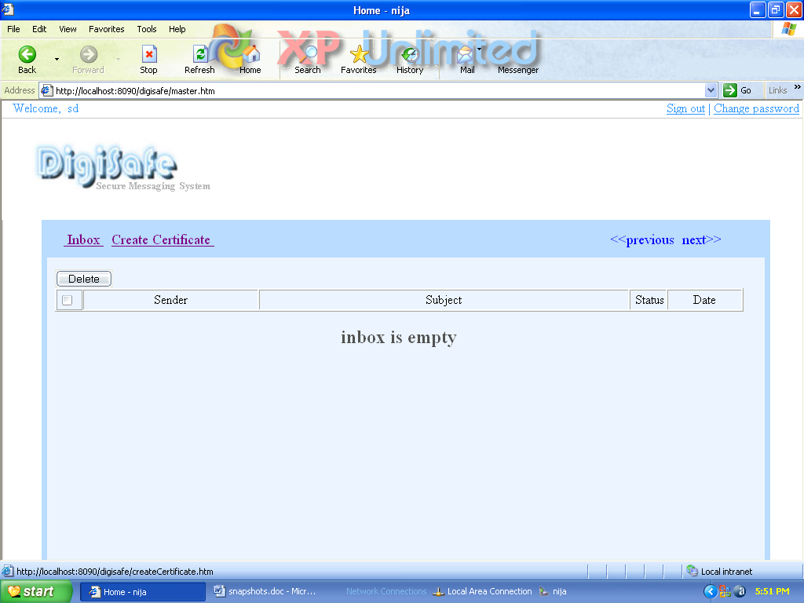

Screen 2 – Create Certificate

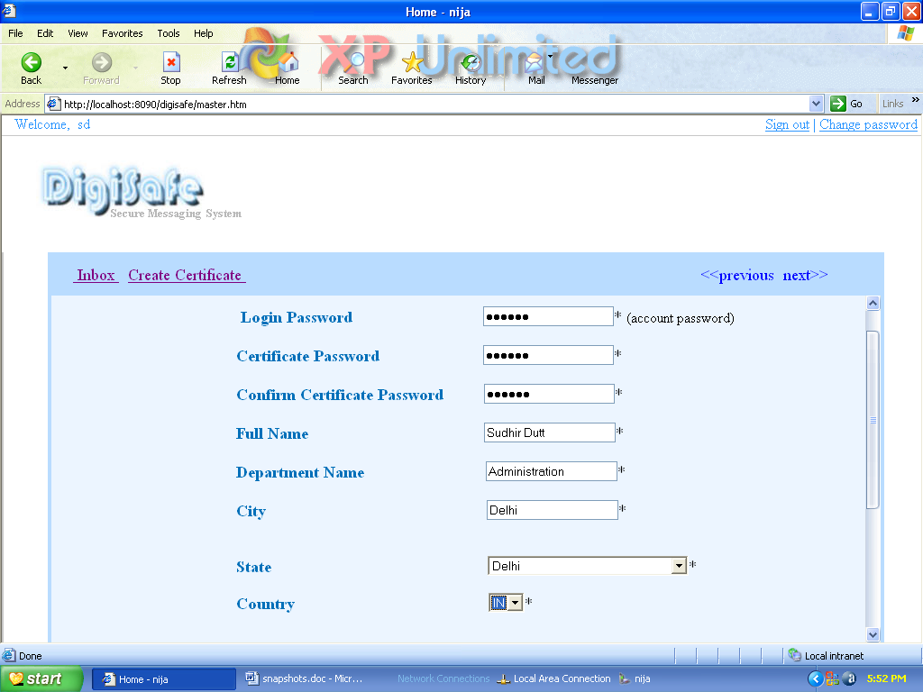

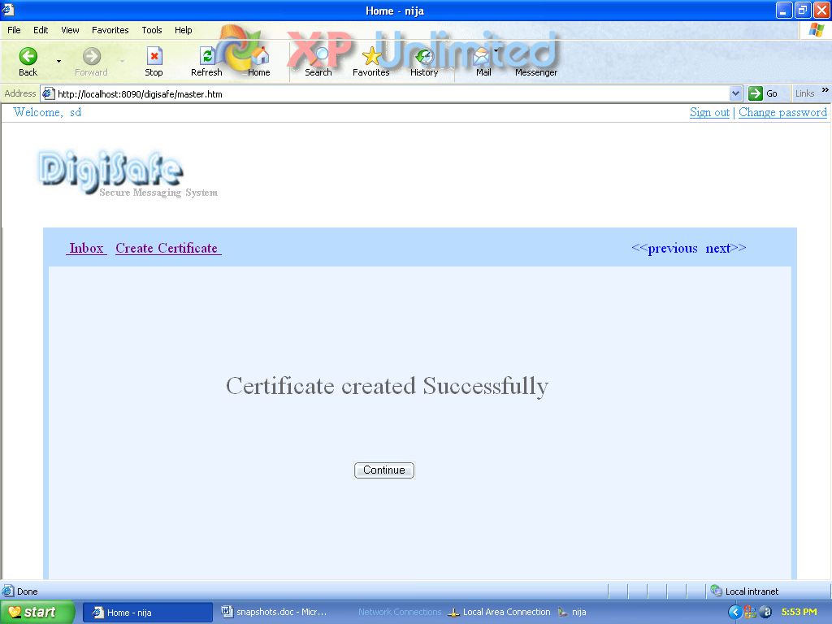

Screen 3 – Compose

- Writing

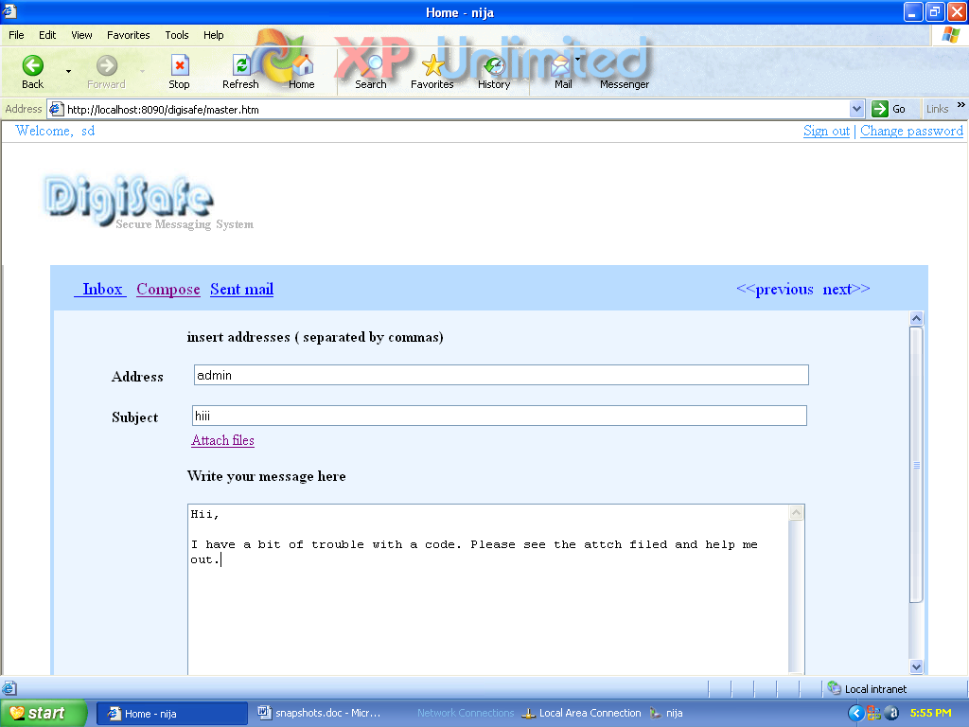

- Attaching files

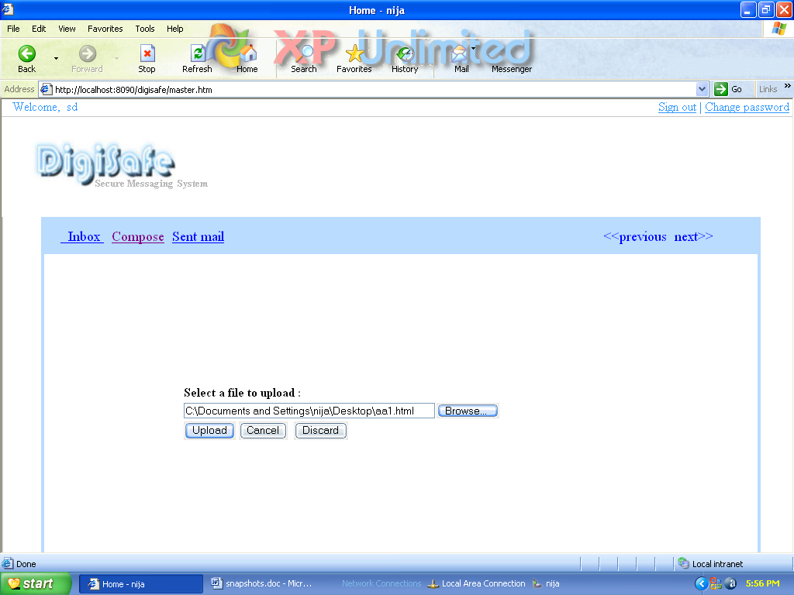

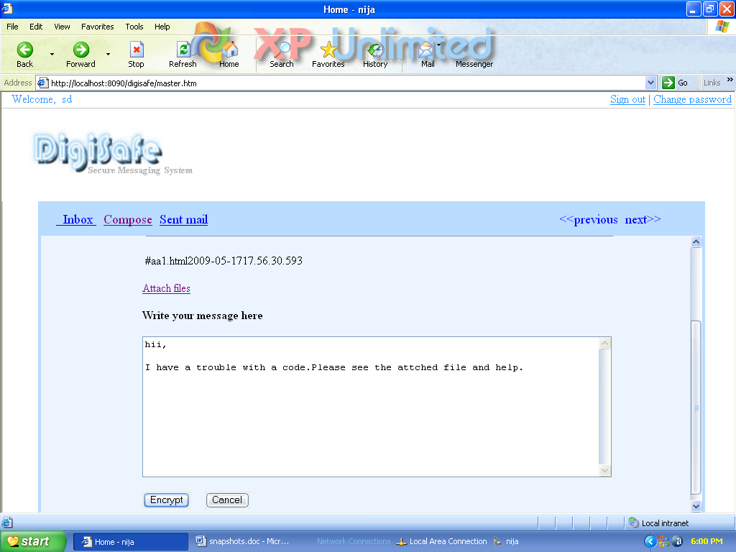

- Encryption

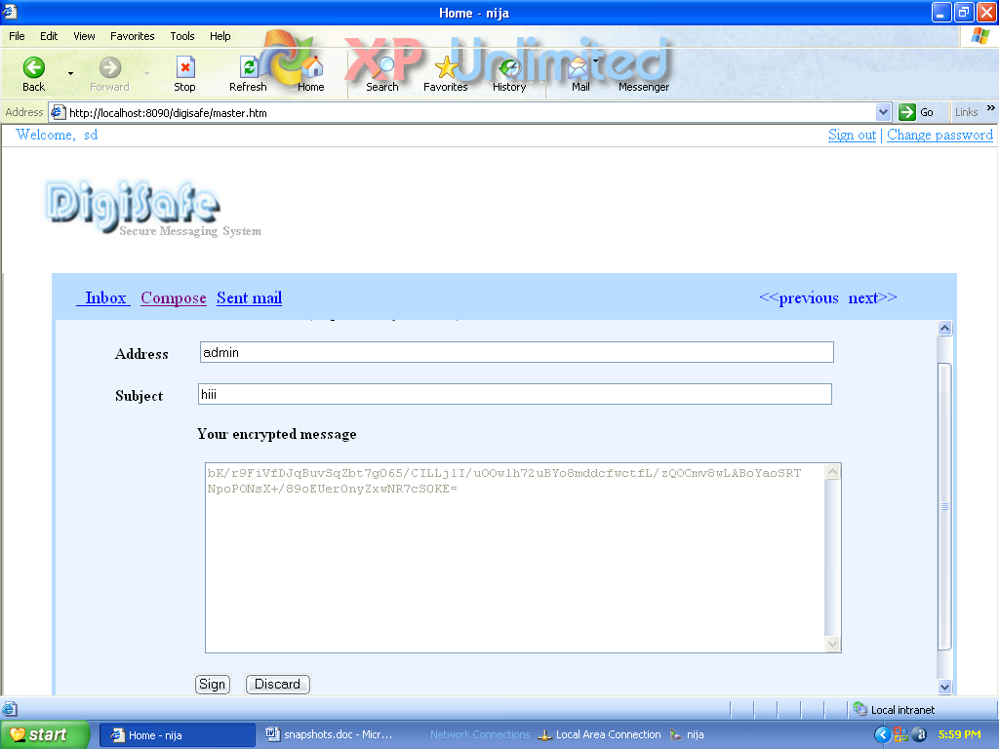

- Signing

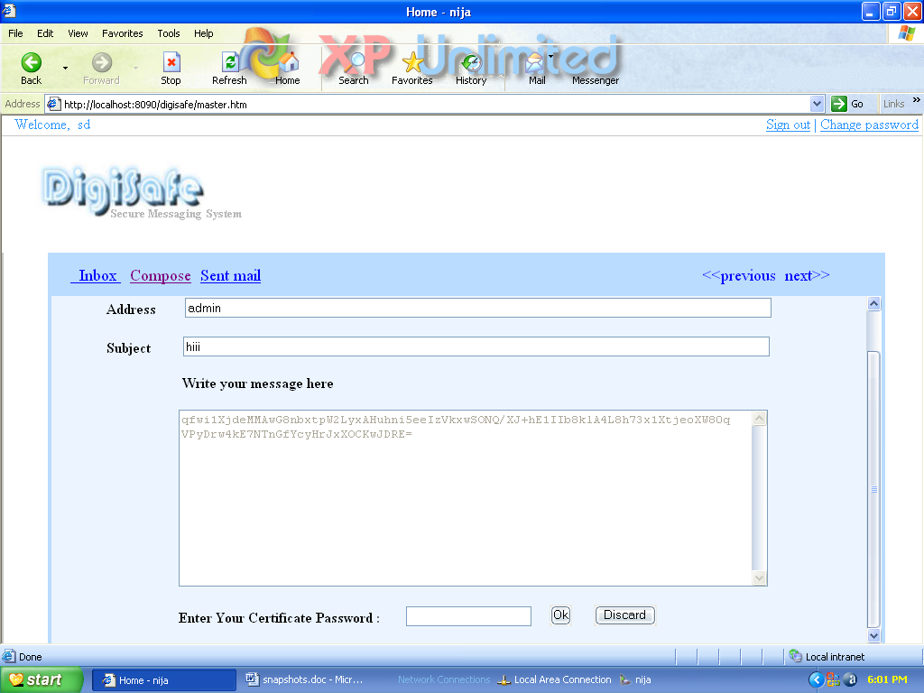

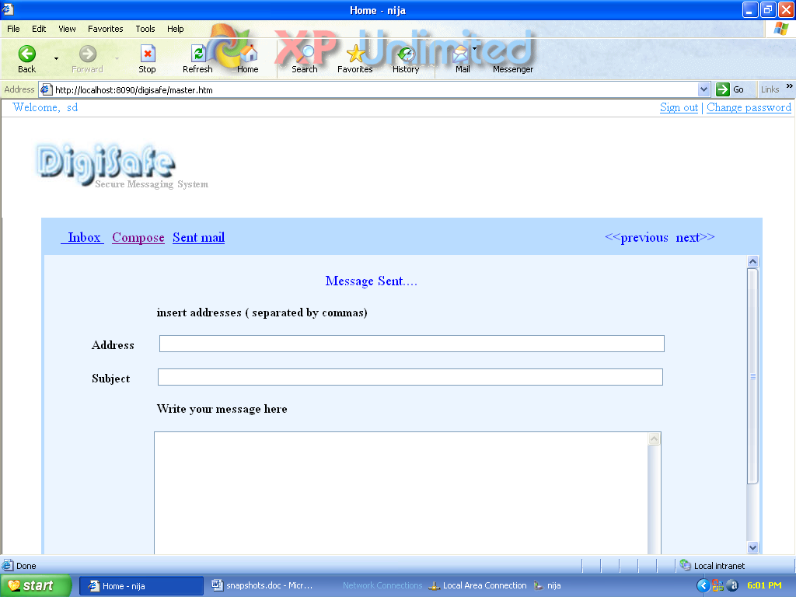

Screen 4 – Registration

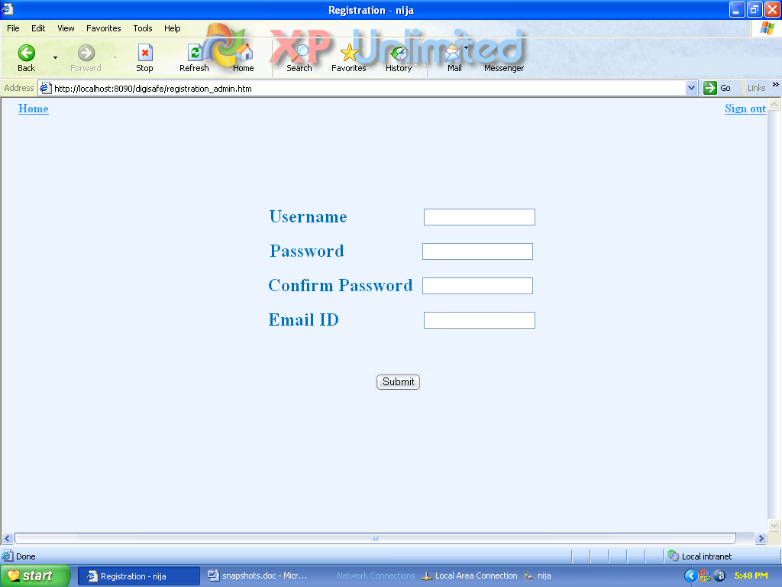

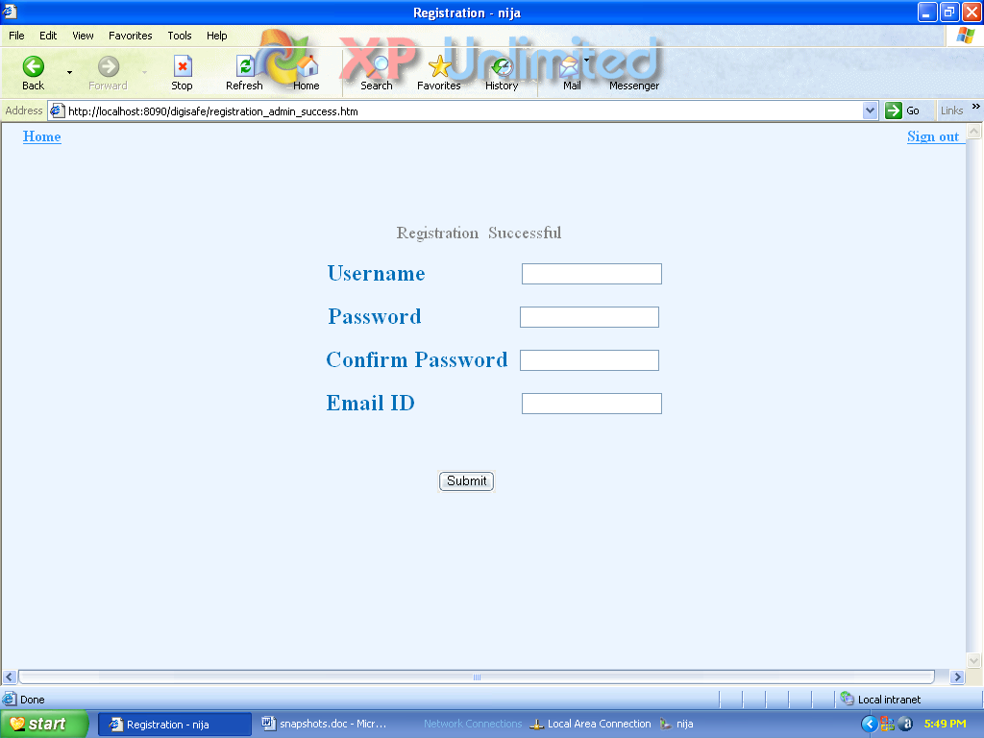

Screen 5 – Edit Profile

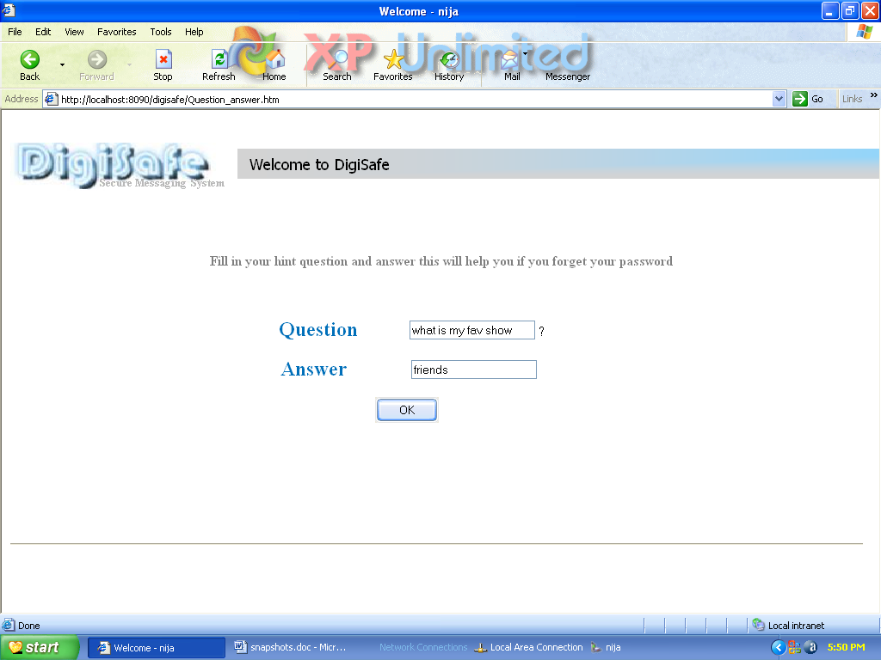

Screen 6 – Change Password

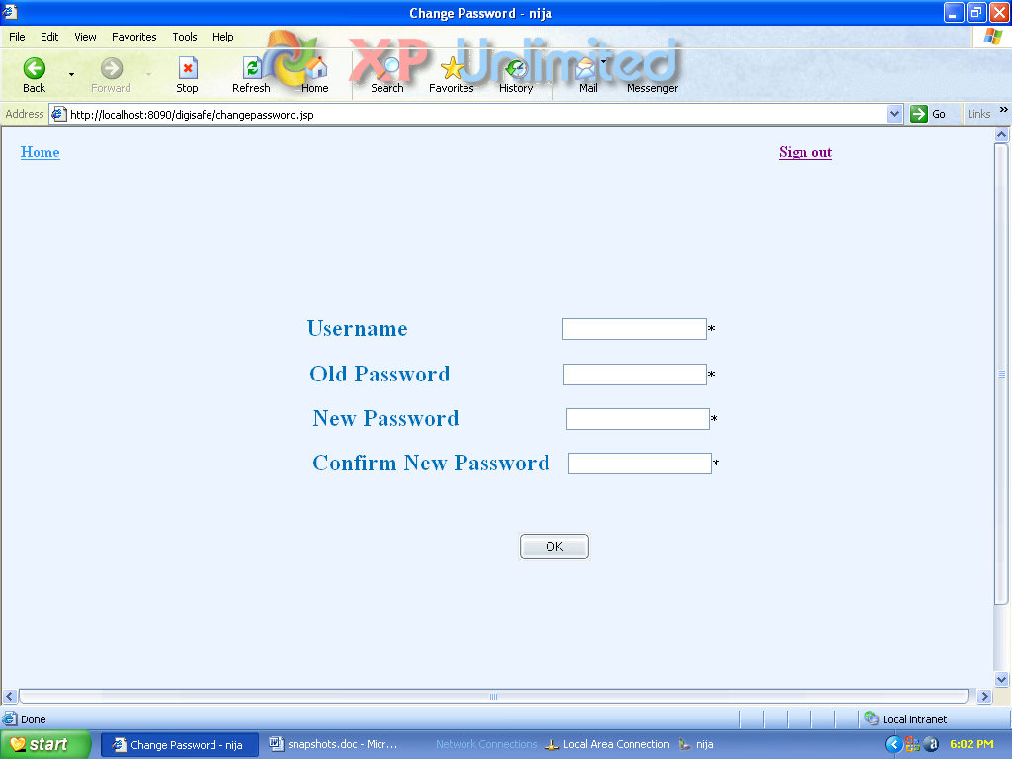

Screen 7 – Forgot Password

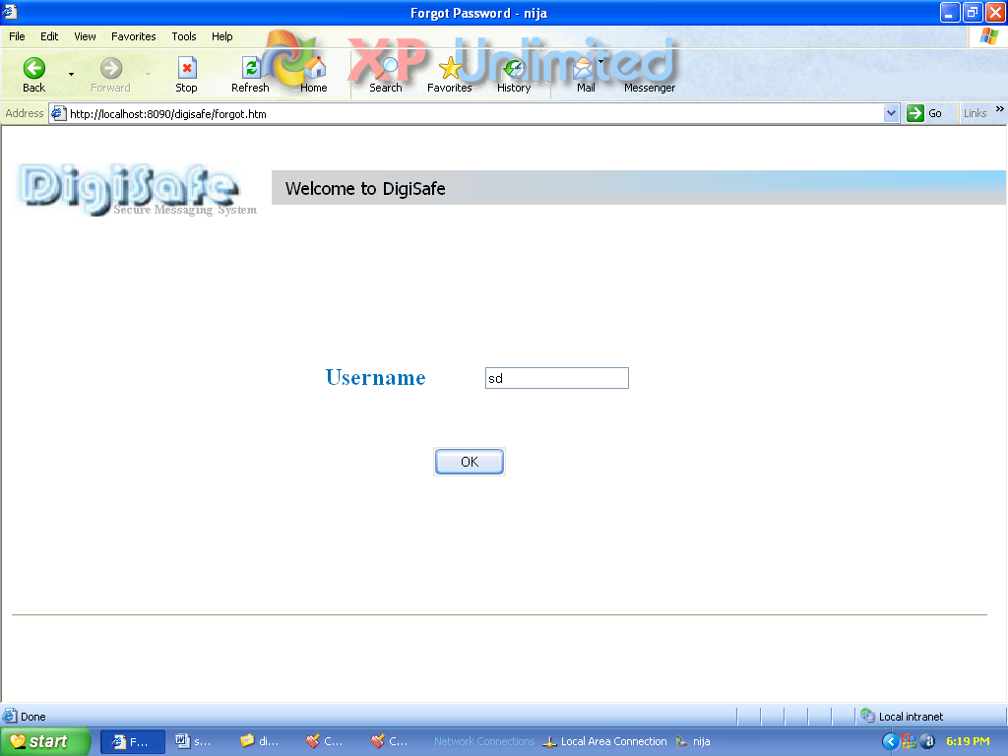

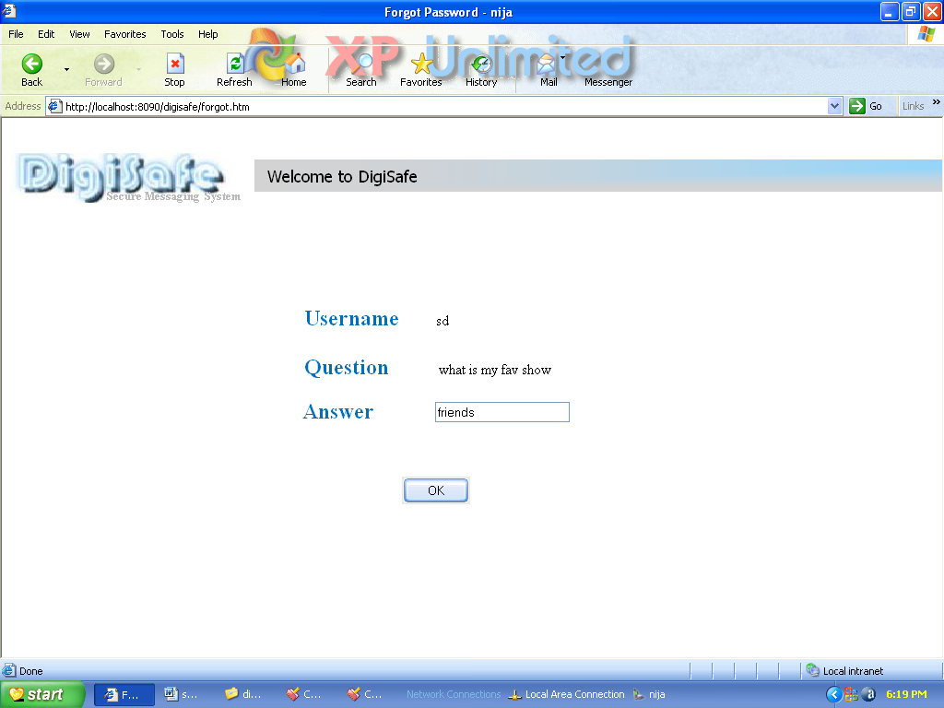

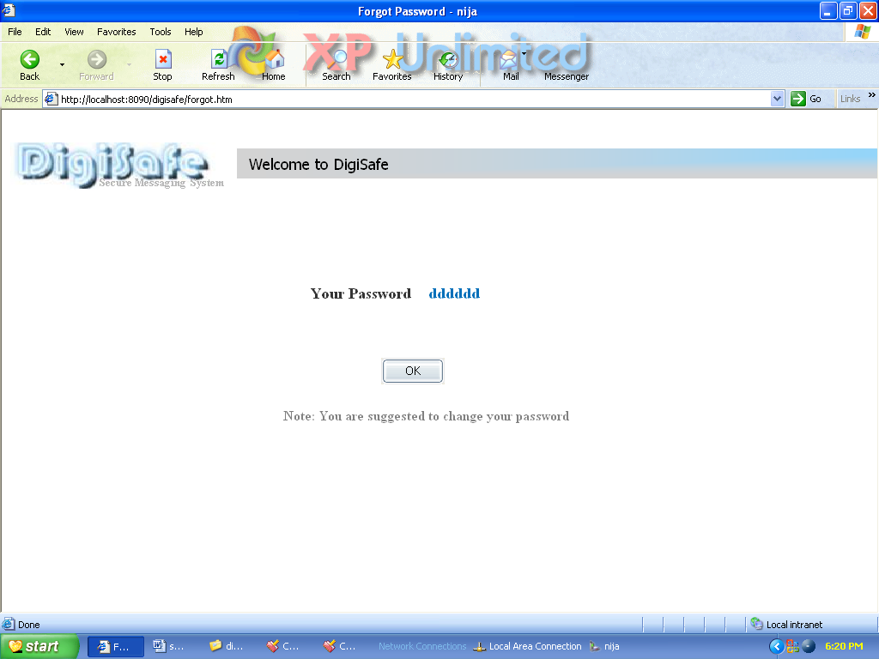

Screen 7 – Sent Mail

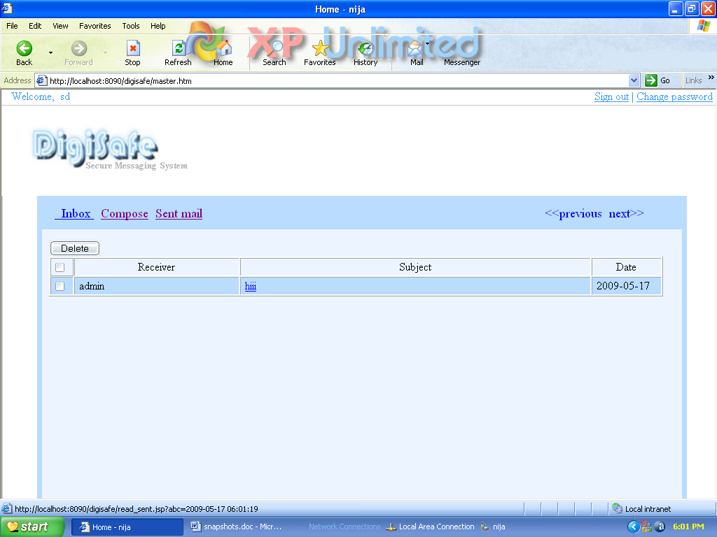

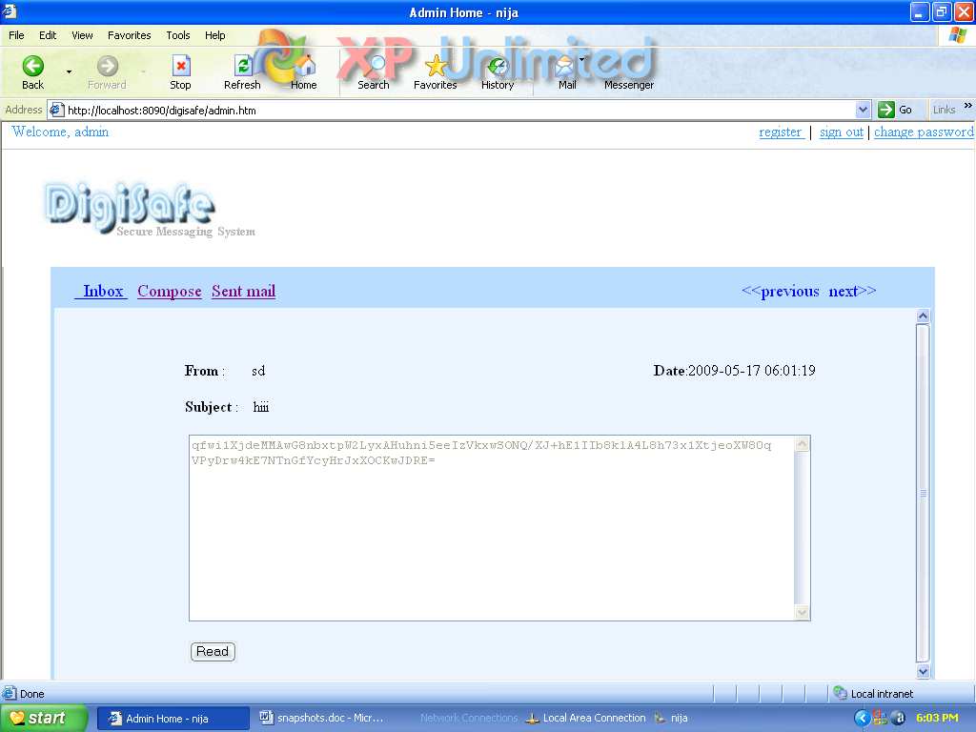

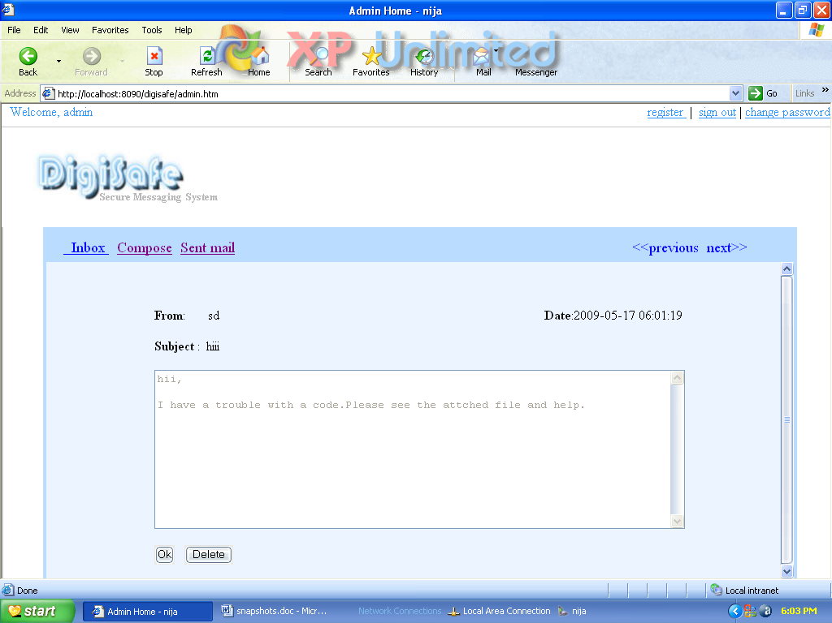

APPENDIX

Appendix

J2EE
Sun Microsystems provides specifications for a comprehensive suite of technologies to solve large scale distributed system problems. This suite is the Java 2 Enterprise Edition, commonly known as J2EE. The J2EE Platform provides a component-based approach to the design, development, assembly, and deployment of enterprise applications.
The J2EE platform is designed to provide server-side and client-side support for developing enterprise, multi-tier applications. Such applications are typically configured as a client tier to provide the user interface, one or more middle-tier modules that provide client services and business logic for an application, and backend enterprise information systems providing data management.
J2EE APIs
- JDBC – Java Database Connectivity
- RMI – IIOP - Remote Method Invocation over Internet Inter-Orb Protocol
- EJB – Enterprise Java Beans
- Java Servlet
- JSP – Java Server Pages
- JMS – Java Message Service
- JNDI – Java Naming and Directory Interface

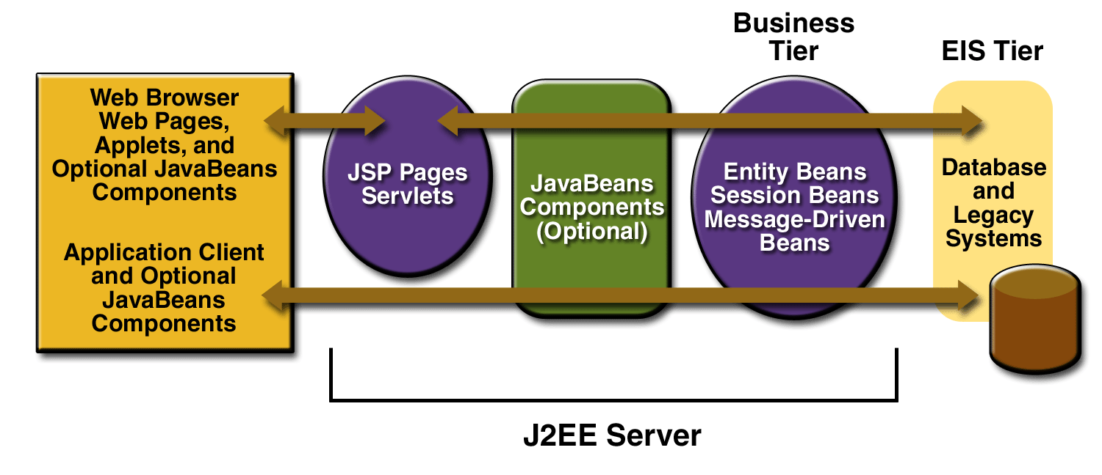
J2EE Technologies

Figure: J2EE Container
J2EE applications are made up of components. A J2EE component is a self-contained functional software unit that is assembled into a J2EE application with its related classes and files and that communicates with other components. The J2EE specification defines the following J2EE components:
- The Component technologies – to hold the business logic. (JSP, Servlets and EJB)
- The Service technologies – to provide supported services to application components (JDBC, JTA, JNDI)
- The Communication technologies – transparent to appln programmer, provide the mechanism for communication among different parts of the application JavaMail, RMI-IIOP)
- J2EE does not specify the nature and structure of the runtime.
- J2EE Container – capability of the runtime to manage application components.
- J2EE APIs specifies the contract between the applications and the container.
- Different Containers – Web, EJB, Applet, application client.
The J2EE platform uses a multi-tiered distributed application model. Application logic is divided into components according to function, and the various application components that make up a J2EE application are installed on different machines depending on the tier in the multi-tiered J2EE environment to which the application component belongs
- Client-tier components run on Client machine.
- Web-tier components run on the J2EE server.
- Business-tier components run on the J2EE server.
- Enterprise information system (EIS)-tier software runs on the EIS server.

Enterprise Java Beans (EJB)
Enterprise JavaBeans (EJB) technology is a J2EE technology for developing business components in a component-based, enterprise Java application. Business components developed with EJB technology are often called Enterprise JavaBeans components or simply "enterprise beans."
- They are re-usable software units containing business logic.
- An EJB is just a collection of Java classes and an XML Request, bundled into a single unit.
- Java classes must follow certain rules and provide certain callback methods.
There are three types of enterprise beans:
- Session beans
- Stateful
- Stateless
- Entity beans
- Bean-managed Persistence (BMP)
- Container-managed Persistence (CMP)
- Enterprise Javabeans Query Language
- Message-driven beans

Session beans
A session bean represents a single unique session between a client and an instance of the bean. A session bean can't be shared. One instance of the bean is tied to a specific client in a specific session. The session bean exposes methods that a client can call to execute business tasks on the server. When Client's session ends, the session bean is no longer associated with that client.

There are two types of session beans: stateful and stateless.
- Stateful
A stateful session bean maintains data about the unique client-bean session in its instance variables. The data represents the state (often called the "conversational state") of that specific session. The conversational state is maintained for the life of Client-bean association. Significantly, this means that the data is maintained across operations.
- Stateless
A stateless session bean does not maintain conversational state for its client. Because a stateless session bean cannot maintain conversational state across methods, it's typically used for one-step tasks, such as sending an email that confirms an online order.
Entity beans
An entity bean represents data in a storage medium, such as a relational database. Each entity bean may correspond to a table in a relational database, and each instance of the bean corresponds to a row in that table. Entity beans are not limited to representing relational databases. They can represent data in other types of data stores, but the majority of enterprise applications that use EJB technology access data in relational databases.
An entity bean can manage its own persistence (this is called bean-managed persistence) or let the EJB container manage it (container-managed persistence). With bean-managed persistence, the entity bean code includes SQL statements that access the database. With container-managed persistence, the EJB container automatically generates the necessary database access calls.

Message Driven Beans
A message-driven bean processes asynchronous messages typically sent through the Java Message Service (JMS) API. Asynchronous messaging frees the message sender from waiting for a response from the message receiver.
A message-driven bean can process messages sent by any J2EE component (such as an application client, another enterprise bean, or a web component) or by a JMS application or system that does not use J2EE technology. Often message-driven beans are used to route messages. This makes them useful in many business-to-business communication scenarios.

Oracle 10g Database & Application Server

Oracle Wwblogic Application Server Enterprise Edition
Includes: Oracle Forms Services, Oracle Reports Services, TopLink, Portal, Discoverer Viewer, Discoverer Plus (Web Functionality), Identity Management (LDAP), Application Interconnect Toolkit, Workflow, Wireless Option, Personalization, and 5 JDeveloper Named User Plus licenses per Processor.
Oracle Database 10g Enterprise Edition
Includes: JServer Enterprise Edition, interMedia, Objects Option, Networking Kit, Objects for OLE, Advanced Replication Option, Distributed Option, Parallel Query Option, (including bitmap indexes and parallel bitmap-star query), SQL*Plus, Visual Information Retrieval and Workflow. Also included are: Advanced Backup & Recovery, Queuing, Advanced, Connection Manager & Pooling, 64-bit option, MPI, OCI, ODBC Driver, Enterprise Manager and Enterprise backup utility.

Other Features of ORACLE

Client/Server (distributed processing) environments | To take full advantage of a given computer system or network, Oracle allows processing to be split between the database server and Client application programs.
Large databases and spaces management | Oracle supports the largest of databases, potentially 100 terabytes in size. To make efficient use of expensive hardware devices, it allows full control of space usage.
Many concurrent database users | Oracle supports large numbers of concurrent users executing a variety of database applications operating on the same data. It minimizes data contention and guarantees data concurrency.
High transaction processing performance | Oracle maintains the preceding features with a high degree of overall system performance.
High availability | Oracle can work 24x7 with no down time for quite a large amount of time.
Controlled availability | Oracle can selectively control the availability of data, at the database level and sub-database level. For example, an administrator can disallow use of a specific application so that the application’s data can be reloaded, without affecting other applications.
Database enforced integrity | Oracle enforces data integrity, “business rules” that dictate the standards for acceptable data. As a result, the costs of coding and managing checks in many database applications are eliminated.
Distributed Systems | For networked, distributed environments, Oracle combines the data physically located on different computers into one logical database that can be accessed by all network users. Distributed systems have the same degree of user transparency and data consistency as non-distributed systems, yet receive the advantages of local database management.  Oracle also offers the heterogeneous option that allows users to access data on some non-Oracle databases transparently.
Portability | Oracle software is ported to work under different operating systems. Applications developed for Oracle can be ported to any operating system with little or no modification.
Compatibility | Oracle software is compatible with industry standards, including most industry standard operating systems. Applications developed for Oracle can be used on virtually any system with little or no modification.
Connection ability | Oracle software allows different types of computers and operating systems to share information across network.
Replicated environment | Oracle software lets you replicate groups of tables and their supporting objects to multiple sites. Oracle supports replication of both data-and schema-level changes to these sites. Oracle’s flexible replication technology supports basic primary site replication as well as advanced dynamic and shared-ownership models.

JavaScript
JavaScript was originally developed by Brendan Eich of Netscape under the name Mocha, later LiveScript, and finally renamed to JavaScript. The change of name from LiveScript to JavaScript roughly coincided with Netscape adding support for Java technology in its Netscape Navigator web browser. JavaScript was first introduced and deployed in the Netscape browser version 2.0B3 in December of 1995. When web developers talk about using JavaScript in Internet Explorer, they are actually using JScript. The choice of name proved to be a source of much confusion.
As of 2006, the latest version of the language is JavaScript 1.7. The previous version 1.6 corresponded to ECMA-262 Edition 3 like JavaScript 1.5, except for Array extras, and Array and String generics. ECMAScript, in simple terms, is a standardized version of JavaScript. The ECMA-357 standard specifies E4X, a language extension dealing with XML.
JavaScript is a prototype-based scripting language with a syntax loosely based on C. Like C, the language has no input or output constructs of its own. Where C relies on standard I/O libraries, a JavaScript engine relies on a host environment into which it is embedded. There are many such host environment applications, of which web technologies are the best-known examples. These are examined first.
One major use of web-based JavaScript is to write functions that are embedded in or included from HTML pages and interact with the Document Object Model (DOM) of the page to perform tasks not possible in HTML alone. Some common examples of this usage follow.
- Opening or popping up a new window with programmatic control over the size, position and 'look' of the new window (i.e. whether or not the menus, toolbars, etc. are visible).

- Validation of web form input values to make sure that they will be accepted before they are submitted to the server.
- Changing images as the mouse cursor moves over them: This effect is often used to draw the user's attention to important links displayed as graphical elements.

Bibliography

Bibliography

Web Resources

- www.java.sun.com
Official Java Website
- www.java.sun.com/developer/onlineTraining/J2EE/Intro2/j2ee.html
Training for J2EE
- www.java.sun.com/j2se/1.4.2/docs/api/index.html
J2SE Online Documentation from Sun
    - www.w3schools.com
JavaScript Tutorials

BOOKS

- API DOCS –JAVA, J2EE, Java Mail, Java Servlets, JSPs
By: Sun Microsystems

- Java2 - The Complete Reference(7TH Edition)
By: Herbert Schildt

- JSP - The Complete Reference
By: Philhanna

- Oracle 10g
By: Ivan Baross

- Software Engineering
By: Roger Pressman

- Head First Servlets & JSP
By: Bryan Bashan, Kathy Sierra & Bert Bates

